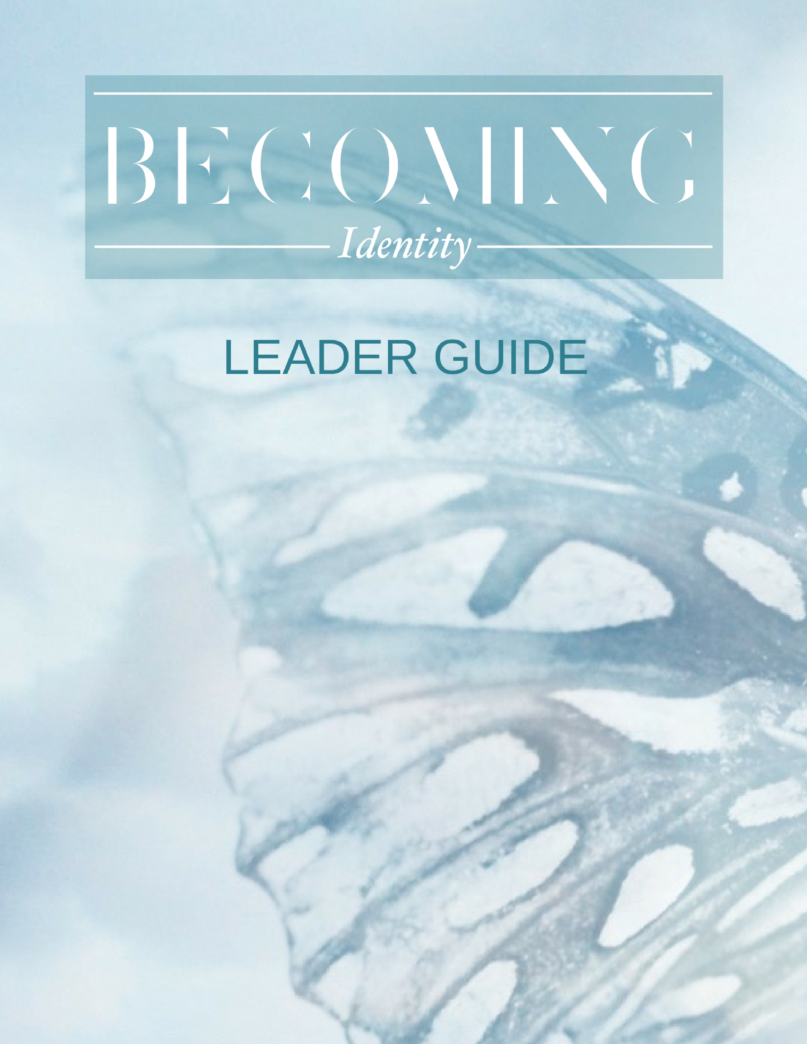

Dear BECOMING Bible Study leaders,
Thank you for joining us and leading a group of women in examining their true identity in Christ! It is not a meager calling to take on such a role, and we commend your passion, time and effort given towards deepening others' faith and expanding God's kingdom through this study.
The BECOMING Team can serve as a resource for you during this 8 week study. We would love to hear from you at any point with questions, thoughts, feedback, or to provide any additional assistance you may need. Our BECOMING Team will be praying for you and the women you lead throughout this study! It is our desire to encourage and equip you, so please do not hesitate to email or call us at any time.
As a quick preparation for the study, we suggest you take a few minutes to read the "Letter from the Editor" of the BECOMING book, found just before the Table of Contents in the front. This "sets the stage" for why Identity is such an important subject for us as women in Christ to tackle and will give you sense of the heart the BECOMING mission. In addition, reading through the Introduction Letter of the Companion Guide, found on pages 2 & 3, will offer some important reminders about organizing a successful group study.
We fully recognize that it is God alone who provides the grace, wisdom, compassion and perseverance to humbly lead one another in Christ. We encourage each of you to spend intentional time with the Lord each day as you engage in this season of leadership, prayerfully asking God to reveal new insights and transform hearts while building community and a deeper love for Him who created and calls us! May your own identity be rooted in our Savior, and may your confidence in Him be evident as you lead.
Always becoming,
Nikki Ickes
Director of Discipleship BECOMING
2 Corinthians 3:18- So all of us who have had that veil removed can see and reflect the glory of the Lord. And the Lord—who is the Spirit—makes us more and more like him as we are changed into his glorious image.
Becoming Leader/Facilitator Information
As a leader for BECOMING: Identity, please know that our team is available to you as a resource, so please don't hesitate to reach out if you need anything.
- Shannon Basso, Chief Editor of BECOMING- shannon@becomingmag.com
- Nikki Ickes, Director of Discipleship- nikki_ickes@yahoo.com
A couple things we'd like to ask each BECOMING Leader:
Please keep each woman in your group before you in prayer! This study is designed to not only present each woman with the Truth about who she is in Christ, but also confront the lies she believes. We know that Satan is called the "accuser" and will do anything he can to keep women from the freedom of Identity that God offers them. As different issues and struggles present themselves each week, it is our privilege to lift up these concerns to God and request that he tear down strongholds! Be diligent in "fighting the good fight" with prayer on behalf of those in your care.
Encourage your group to finish strong! As the weeks go by in study, we understand that women tend to drift but encourage your groups from the beginning to finish strong and get everything they can out of the study! The very last Session (#8) is truly special- we don't want anyone to miss it.
As a group leader, here are just a few points of consideration that will help make your group time as transformative as possible. These points are also listed in the front of the Companion Guide:
Establish trust. BECOMING is meant to challenge you to dig deeper and think bigger. Some of the questions will probe a little further into your spiritual life than you might want, and invite you to thoughtfully consider real concerns and issues. For this reason, it is absolutely imperative that you establish trust from the beginning within the group. Your time together is sacred and confidential, and in most cases, should not to be discussed outside the boundaries of the group. For real revelation and growth to occur, each woman must be committed to preserving the trust of others. Commit to this.

Read carefully. Try to read with an open heart and mind without bringing preconceived assumptions to the material. Read first for enjoyment. Give thanks for the truth of who God is and who you are in Him. Notice any of the subtle ways the Holy Spirit nudges you. Maybe certain words stick in your mind or a concept really resonates with where you are in life. Pay attention to these things-they may be a sign of how God wants you to grow.
A second reading would be beneficial to dig deeper. Quite possibly, you’ll encounter a thought or a term that is unfamiliar. Take the time to research and explore the content that piques your interest. (**Check out the Glossary at the end of the BECOMING book!!) Or, maybe an article presents an idea you’re not sure you agree with. That’s a great opportunity to discover for yourself what Scripture says, and then take it to your group for discussion.
Answer honestly. Be as vulnerable as God is calling you to be. So much of our growth towards maturity comes from our willingness to acknowledge patterns and areas of struggle. God wants to transform us, but we must invite the transformation! So, do your best to open up when appropriate. You never know, others in your group may greatly benefit from your vulnerability and insight.
Invite accountability. Ask God to provide at least one other believer who will walk this journey with you, someone who will encourage you (and gently prod you, when necessary) to keep moving forward to discover His next steps. The Christian life is hard, and we all benefit from having an ally to embolden and support us along the way.
In closing, our team's deep desire for each woman that participates in this study is that she simply takes the next step toward Jesus, one step as a new creation. Transformation is a life-long journey as God renews us day by day. May we inspire each other to remain “on the way.”
Always becoming,
Shannon Basso
Editor, BECOMING

Email to Leaders Prior to Session One

Hello Sisters in Christ! We encourage you to take some time getting to know the women in your groups with introductions and ask what each member hopes to gain from this study and/or learn about God and themselves during these 8 weeks together! The BECOMING Team also wanted to provide you with some opening discussion questions for you to utilize during your group time this week.

Opening Questions for Week One of BECOMING Identity Study: Please read aloud the "Letter from the Editor" from the BECOMING book. The letter is located in the pages before the Table of Contents in the front of the book. Then, lead your group in answering the following questions:

- If someone were to simply ask you today, "Who are you?", how would you answer?

- Specific roles, career, physical appearance, family background, personal successes or failures. Can you think of a time in your life when any of these examples have defined your understanding of who you are? Share if you are comfortable.

- Can you identity with the "big, black pot of soup" example? How?

- When we meet Jesus and believe in Him as the Savior of our lives, he gives us an all new Identity! As C.S. Lewis says, God "came to produce a new kind of man." Can you think of some ways you struggle to live as a New Creation in Christ? In other words, are there some areas of life where you feel stuck living as if you haven't been changed?

- In this 8 week study, we will explore the topics of Identity Lost (how we lost our identity and why this subject creates so much struggle for us), and the truths that We Are: Ezer, Heirs, Loved, God's Workmanship, Disciples, Theologians, and New Creations. Which of these topics is most intriguing to you? Any that "scare" you?

Extra question should you need it:
The apostle Paul wrote, "The body of Christ is built up as each one does his part." Our differences are important and God-given, and they are put in place to strengthen the church! How much importance do you place on your uniqueness, special qualities, or talents? If one of these special qualities were to be taken away for some reason, how much would it affect your perception of your self-worth?
Leaders: Please take a few minutes to pray aloud over the women in your group, asking God to open them up to the individual ways the Spirit would speak into their lives during this study!

Always becoming,

Shannon Basso and Nikki Ickes

BECOMING: Identity Eight Week Session Structure
Depending on your small groups and/or availability to provide them their books and study guide ahead of time, there are one of two formats which work well for an 8-week BECOMING: Identity study. (There are many other options so feel free to play around with whatever suits your group best- another option would be doing a full 14-week study or breaking it down into two 7-8 week sessions, taking one article per week. Please let the BECOMING Team know if you have any questions!)
If you are not able to provide materials prior to your first session together, you may decide to make this a 9-week study where the first session would be for introductions, handing out materials, and discussing the expectations and format of the study. If this is the format you chose, you may also consider showing Video One on “Identity Lost” (link provided in week One Additional Scripture Study/Resources) to introduce the study and first article to your women.
The following format is recommended if materials can be provided to participants at least one week prior to meeting together for the first time.

Session One: before meeting together, read the “Letter from the Editor” and “Identity Lost” article/study questions to discuss after introductions during your first time together.
Home study- Read through “We Are Ezer” and “We Are Image Bearers” articles and complete corresponding study guide questions.
Additional Scripture Study/Resources
Identity Lost
- Video link- https://www.youtube.com/channel/UCU5TJcTBGpAbhr_tlSNACsQ -Video #1
- Article Concepts:
Seek- John 8:32
Abide- John 15, 1 John 2:17
Give- Acts 20:35
Confess- Psalm 51:10, 2 Corinthians 7:9-10, James 5:16; 1 Peter 5:6-7; 1 John 1:9
- Additional Scripture for study:
Luke 11:34-35 2
Corinthians 10:5
Colossians 3:1-12
Hebrews 12:1-3

Session Two: Discuss “We Are Ezer” and “We Are Image Bearers” articles
Home study- Read through “We Are Heirs” and “We Are Loved” articles and complete corresponding study guide questions.

Additional Scripture Study/Resources
We Are Ezer
- Video link- https://www.youtube.com/channel/UCU5TJcTBGpAbhr_tlSNACsQ Video #2
- Additional Scripture for study:
Genesis 2:18, 21-24
Deuteronomy 33:7, 29
Psalm 30:10, 33:20, 54:4, 70:5, 115:9-11, 146:5

We Are Image Bearers
- Suggested video link- “The Image of God” by The Bible Project: https://www.youtube.com/watch?v=YbipxLDtY8c
- Article Concepts:
Invitation- Isaiah 55:1-3, Matthew 11:28-30, Matthew 28:18-20
Nurture- Genesis 1:28
Partner- John 12:49-50, John 15:16 & 26, John 17:20-22
- Additional Scripture for study:
Genesis 1:26-27
1 Corinthians 11:7
Ephesians 4:24
Colossians 1:15, 3:10
Hebrews 1:3 1 John 3:2

Session Three: Discuss “We Are Heirs” and “We Are Loved” articles
Home study- Read through “We Are Saints” and “We Are Redeemed” articles and complete corresponding study guide questions. See Additional Scripture Study/Resource Page for further study into the Bible on these topics.
Additional Scripture Study/Resources
We Are Heirs
- Video link- https://www.youtube.com/channel/UCU5TJcTBGpAbhr_tlSNACsQ Video #3
- Additional Scripture for study:
John 1:12-13
Romans 8:14-17
Galations 4:4-7
Ephesians 1:4-6, 13-14
1 John 3:1
We Are Loved
- Video link- https://www.youtube.com/channel/UCU5TJcTBGpAbhr_tlSNACsQ Video #4
- Additional Scripture for study:
Psalm 100:5; 103: 9, 11; 136: 1-3
Lamentations 3:22-23
Zephaniah 3:17
John 3:16; 15: 9-17; 16:27
Romans 5:8; 8:31-39
1 Corinthians 13:4-8
Ephesians 3:17-19
2 Timothy 1:7-10
1 Peter 5: 7, 10
1 John 4:7-16, 19

Session Four: Discuss “We Are Saints” and “We Are Redeemed” articles
Home study- Read through “We Are God’s Workmanship” and “We Are Disciples and Disciple Makers” articles and complete corresponding study guide questions. See Additional Scripture Study/Resource Page for further study into the Bible on these topics.
Additional Scripture Study/Resources
We Are Saints
- Additional Scripture for study:
Psalm 16:3; 50:5-6; 97:10
Isaiah 61:3
Daniel 7:18 John 10:27-30; 12:23-26
1 Corinthians 1:2
Ephesians 2:13-22
Philippians 1:6; 4:21-22
2 Thessalonians 1:10
1 Peter 1:16; 2:9
Jude 1:3
We Are Redeemed
- Additional Scripture for study:
Ezekiel 36:26
Mark 14:32-36
1 Corinthians 6:19
Galations 3:13; 4:4-7
Ephesians 1:7-10
Colossians 1:14
1 Timothy 2:5-6
Titus 2:14
Hebrews 9:12-15
1 Peter 1:18-19

Session Five: Discuss “We Are God’s Workmanship” and “We Are Disciples and Disciple Makers” articles
Home study- Read through “We Are Theologians” and “We Are Ambassadors” articles and complete corresponding study guide questions. See Additional
Scripture Study/Resource Page for further study into the Bible on these topics.
Additional Scripture Study/Resources
We Are God’s Workmanship
- Video link- https://www.youtube.com/channel/UCU5TJcTBGpAbhr_tlSNACsQ Video #5
- Additional Scripture for study:
Genesis 1:27
Psalm 8:3-6; 139: 1-5, 13-16, 23-24
Proverbs 3:5-6
Matthew 10:29-31
Luke 12:7
Ephesians 2:1-22 (highlight v.10)
Philippians 1:6
Colossians 3:23
Hebrews 2:5-9

III. What Does God Call Us To Be?
We Are Disciples and Disciple Makers
- Video link- https://www.youtube.com/channel/UCU5TJcTBGpAbhr_tlSNACsQ Video #6
- Additional Scripture for study:
Matthew 28:18-20
Luke 5: 16; 6:12-16; Luke 11
Mark 1:35
John 1:1-5, 10-12, 16-18
1 Corinthians 12:4-11
2 Timothy 3:16-18

Session Six: Discuss “We Are Theologians” and “We Are Ambassadors” articles
Home study- Read through “We Are Jars of Clay” and “We Are Builders of the Body” articles and complete corresponding study guide questions. See Additional Scripture Study/Resource Page for further study into the Bible on these topics.
Additional Scripture Study/Resources
We Are Theologians
- Video link- https://www.youtube.com/channel/UCU5TJcTBGpAbhr_tlSNACsQ Video #7
- Additional Scripture for study:
Psalm 34:8 Hosea 6:3
Matthew 4:17, 19; 11:29
John 14: 16, 26
Ephesians 1:15-23; 6:16
Hebrews 5:11-6:1

We Are Ambassadors
- Additional Scripture for study:
John 20:21 (NIV) Acts 1:8
2 Corinthians 5:18-20 (NIV)
Colossians 3:10, 12
Revelation 22:4 (The Message)

Session Seven: Discuss “We Are Jars of Clay” and “We Are Builders of the Body” articles and complete corresponding study guide questions. See Additional Scripture Study/Resource Page for further study into the Bible on these topics.
Home Study- Read through “New Creations: Becoming in Hope” article
Additional Scripture Study/Resources
We Are Jars of Clay
- Additional Scripture for study:
Psalm 91; 96:1-6
2 Corinthians 4:5-9
Ephesians 5:19-20
Philippians 1:12-14, 29
James 1:2-4
1 Peter 5:12-13

We Are Builders of the Body
- Additional Scripture for study:
Jeremiah 29:5-7
Romans 12:4-8
1 Corinthians 12: 12-27
Ephesians 1:22-23; 4:11-16
Colossians 1:24-29
1 Peter 2:5-7
Hebrews 3:3-4

Session Eight: Discuss “New Creations: Becoming in Hope” article and CELEBRATE your true IDENTITY IN CHRIST with a fellowship/social event or potluck to the last session together!
New Creations: Becoming in Hope
- Video link- https://www.youtube.com/channel/UCU5TJcTBGpAbhr_tlSNACsQ Video #8
- Additional Scripture for study:
Psalm 39:7
Lamentations 3:22-23
Romans 8: 18-26;
15:13 Colossians 3:1-4
1 Peter 1:3-9

Becoming
I ask myself, “Who am I becoming?”
Who do I want to become?
Am I growing? Learning? Stretching?
Risking? Trusting? Maturing?
Or am I stuck, complacent, or comfortable as I am?
Jesus, I ask you, who do you want me to become?
Am I listening to you? Talking with you?
Imitating your actions? Following your lead?
Responding to your nudges and invitations?
Am I participating with you in my process of becoming?
Lord, help me be open to change to become more like you Jesus, transform me by your love, let your power come through
Help me believe I can become who you want me to be
That I can be healed, transformed, forgiven and set free
Jesus, help me keep my eyes fixed on you
Always keeping your kingdom goals in view
When I feel afraid and stuck in my ways
Help me want to change, empower my days
Jesus, fill me with your powerful Spirit
I want to feel you right here by my side
Nurture your abundant life in me
Please be my constant guide
So that I can courageously become
The only one you designed me to be
Bold and brave and joyfully confident
Because you live strongly in me!

© Rosalind Renshaw; posted March 16, 2016

